Name Bilal Abid Abbasi

Class 1 semester

Pf lab assignment

Iqra University
Islamabad Campus Fall Semester 2025

LAB TASK 7
Course Code: CSC 131 | Course Title: Programming Fundamental
Teacher’s Name: Mr. Ilyas Badshah | Total Marks: 10
Deadline: 10 Jan 2026 | Time: 11 59 pm

1. Prime number check (repeat until negative number)

Program
#include <iostream>
using namespace std;

int main () {
int num;

do {
cout << "Enter a number (negative to exit): ";
cin >> num;

if (num < 0)
break;

int i = 2, isPrime = 1;

if (num <= 1)
isPrime = 0;
else {
while (i <= num / 2) {
if (num % i == 0) {
isPrime = 0;
break;
}
i++;
}
}

if (isPrime)
cout << "Prime number\n";
else
cout << "Not a prime number\n";

} while (num >= 0);

return 0;
}
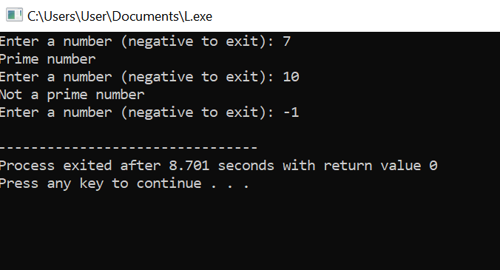

Sample Output
Enter a number (negative to exit): 7
Prime number
Enter a number (negative to exit): 10
Not a prime number
Enter a number (negative to exit): -1

2. Calculator using do-while loop

Program
#include <iostream>
using namespace std;

int main () {
int a, b, choice;
char again;

do {
cout << "Enter two numbers: ";
cin >> a >> b;

cout << "1. Add 2.Subtract 3.Multiply 4.Divide\n";
cout << "Choose operation: ";
cin >> choice;

if (choice == 1)
cout << "Result = " << a + b << end;
else if (choice == 2)
cout << "Result = " << a - b << endl;
else if (choice == 3)
cout << "Result = " << a * b << endl;
else if (choice == 4)
cout << "Result = " << a / b << endl;
else
cout << "Invalid choice\n";

cout << "Do you want to continue? (y/n): ";
cin >> again;

} while (again == 'y' || again == 'Y');

return 0;
}
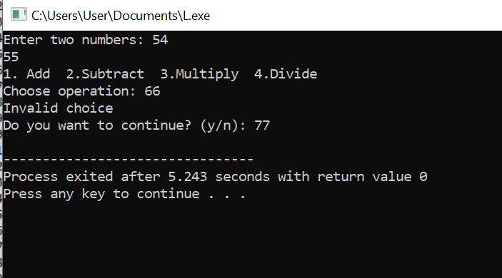

3. Sum of positive integers (stop on negative)

Program
#include <iostream>
using namespace std;

int main() {
int num, sum = 0;

do {
cout << "Enter a positive number (negative to stop): ";
cin >> num;

if (num > 0)
sum += num;

} while (num >= 0);

cout << "Sum = " << sum;
return 0;
}
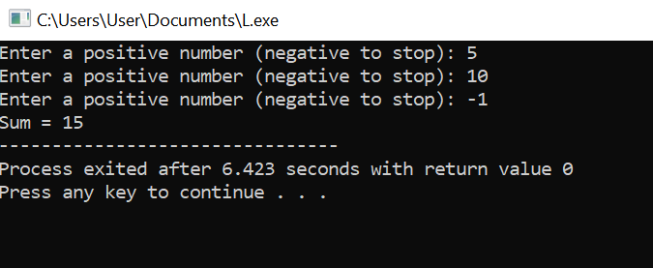

Sample Output
Enter a positive number (negative to stop): 5
Enter a positive number (negative to stop): 10
Enter a positive number (negative to stop): -1
Sum = 15

4. Palindrome word check (exit to stop)

Program
#include <iostream>
using namespace std;

int main() {
string word;

do {
cout << "Enter a word (type exit to stop): ";
cin >> word;

if (word == "exit")
break;

string rev = "";
for (int i = word.length() - 1; i >= 0; i--)
rev += word[i];

if (word == rev)
cout << "Palindrome\n";
else
cout << "Not a palindrome\n";

} while (true);

return 0;
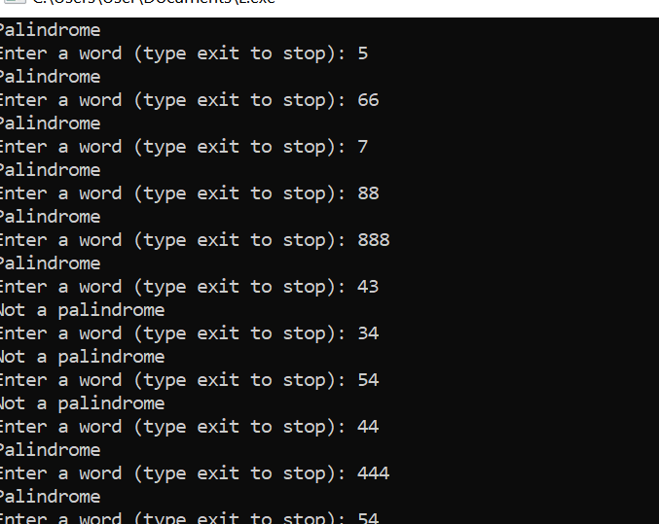
}

Sample Output
Enter a word (type exit to stop): level
Palindrome
Enter a word (type exit to stop): hello
Not a palindrome
Enter a word (type exit to stop): exit

5. Sum of even and odd numbers (stop on 0)

Program
#include <iostream>
using namespace std;

int main() {
int num, evenSum = 0, oddSum = 0;

do {
cout << "Enter number (0 to stop): ";
cin >> num;

if (num == 0)
break;

if (num % 2 == 0)
evenSum += num;
else
oddSum += num;

} while (num != 0);

cout << "Even Sum = " << evenSum << endl;
cout << "Odd Sum = " << oddSum << endl;

return 0;
}
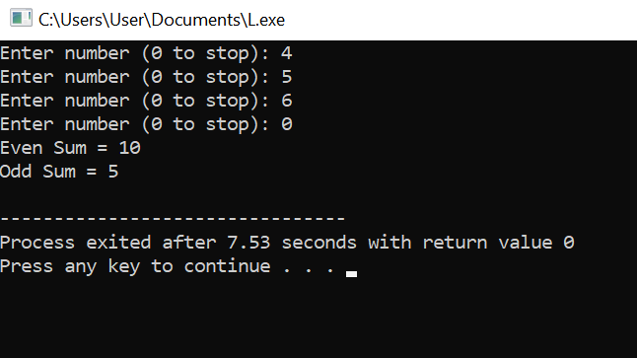

Sample Output
Enter number (0 to stop): 4
Enter number (0 to stop): 5
Enter number (0 to stop): 6
Enter number (0 to stop): 0
Even Sum = 10
Odd Sum = 5

6. Count digits using do-while

Program
#include <iostream>
using namespace std;

int main() {
int num, count = 0;

cout << "Enter a positive number: ";
cin >> num;

do {
count++;
num /= 10;
} while (num > 0);

cout << "Number of digits = " << count;
return 0;
}

Sample Output
Enter a positive number: 12345
Number of digits = 5
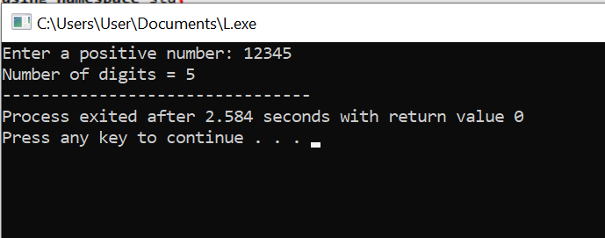

7. Power calculation using do-while

Program
#include <iostream>
using namespace std;

int main() {
int base, exp, result = 1, i = 1;

cout << "Enter base: ";
cin >> base;
cout << "Enter exponent: ";
cin >> exp;

do {
result *= base;
i++;
} while (i <= exp);

cout << "Result = " << result;
return 0;
}
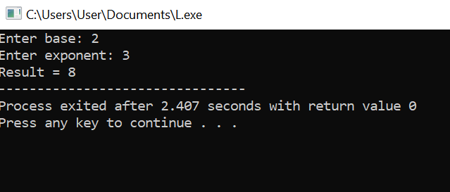

Sample Output
Enter base: 2
Enter exponent: 3
Result = 8

